1st Main Program Layout at Server Computer: (Apply for Nail & SPA Template)
Depends on different business. For instance, if Nails & Salon then it will display layout below. The only difference is background layout BUT all features are the same

Store Name
- Every time employee select button then need to enter EmployeeID or swipe EmployeeID or using fingerprint.
  - Service: only service by employee or waiter/waitress
  - Product: Customer can order products
  - Appointment: Display booking appointment when customer want to reservation or booking to customer or anyone.
  - Customer Walk-in: List all customer walk-in can select in menu and print out service slip or customer waiting list.
  - Credit Card Adjustment: Manager or Owner can add tip, refundable to customer or void ticket
  - Daily Report: Employee or Waiter/Waitress can see daily transaction after enter their own ID
  - Text Message / eMarketing: Manager or Owner can send SMS or email to clients for any promotions (i.e: DOB, Anniversary, Fatherday, motherday, Thanksgiving, New Year, …..)
  - Gift Card: Manager or Owner can sell or edit gift card
  - Membership Card: Manager or Owner can sell or give customer a VIP Card. Display customer profile if swipe membership. If not, search by Name, Telelphone, email, or membershipID.
  - Announcement: Manager or Owner can enter special daily Announcement to Employee or Waiter/Waitress.
  - Customer: Keep track all customer information, can add, update, change, active, in-active
  - Open Cash Drawer: Allow employee can open cash drawer by permission access
  - Back Office: Only Manager or Owner allow to control or change information.
  - Clock In/Out: Any worker needs to lock in when come to work and lock out when they leave.
  - “VIP NAILS SALON”: Name of Store when registered online
  - “Visa and Maser”: When registered to use credit card directly process from computer
  - All background pictures do not store in Database. Need to locate at local folder. (i.e: \program file\ePOSTouch\image)

2nd Main Program Layout of Salon Store at Server Computer
Employee Name: means Nancy.
Ticket #: means ticket number of each employee name.
Total Ticket Number: means total ticket number of each store.
Daily Income: means daily income of each employee name.
Select Customer: means if existing customer then search customer by name, telephone,
or customer membership ID
Category (Prev, Next): Product and Service Category
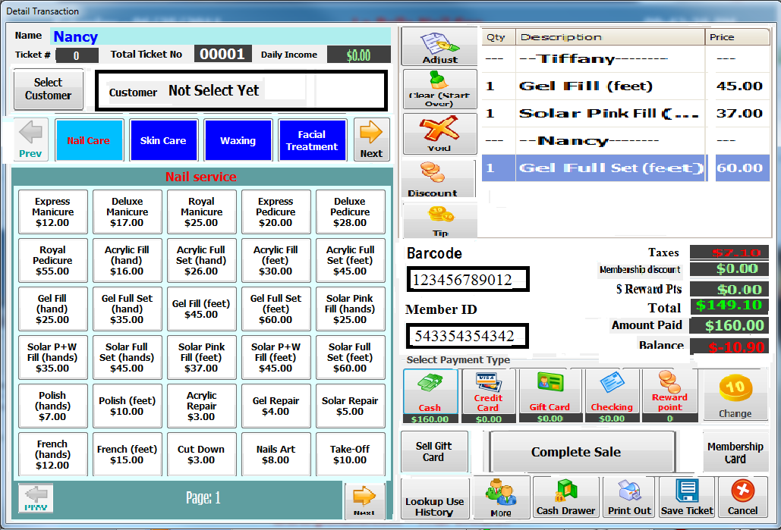
Nail Service: Means items per category.
Adjust: Means pricing per item.
Clear (Star Over): Clears all current transactions.
Void: Deletes a current transaction.
Discount: Discount by dollar or percentage of all items.
TIP: Tip by cash, checking, or gift card.
Barcode: When sell product(s)
Member ID: If client had VIP membership card then swipe or barcode.
CASH: Paid by CASH
CREDIT CARD: Paid by Credit Card
GIFT CARD: Paid by Gift Card
CHECKING: Paid by personal check or company check
REWARD POINT: If customer wants deductible money by reward points.
CHANGE: If customer gives more than total amount then we need to change the different amount.
SELL GIFT CARD: When sells gift card to customer.
COMPLETE SALE: After customer paid by type of payment then press completed.
LOOKUP HISTORY: Display all transaction of employee.
MORE: If it has several services then need more employees served to customer.
CASH DRAWER: When employee wants to change money to customer.
SAVE TICKET: Hold transaction when other employee wants to use computer
CANCEL: Cancel this transaction

2nd Main Program Layout of Restaurant at Server Computer
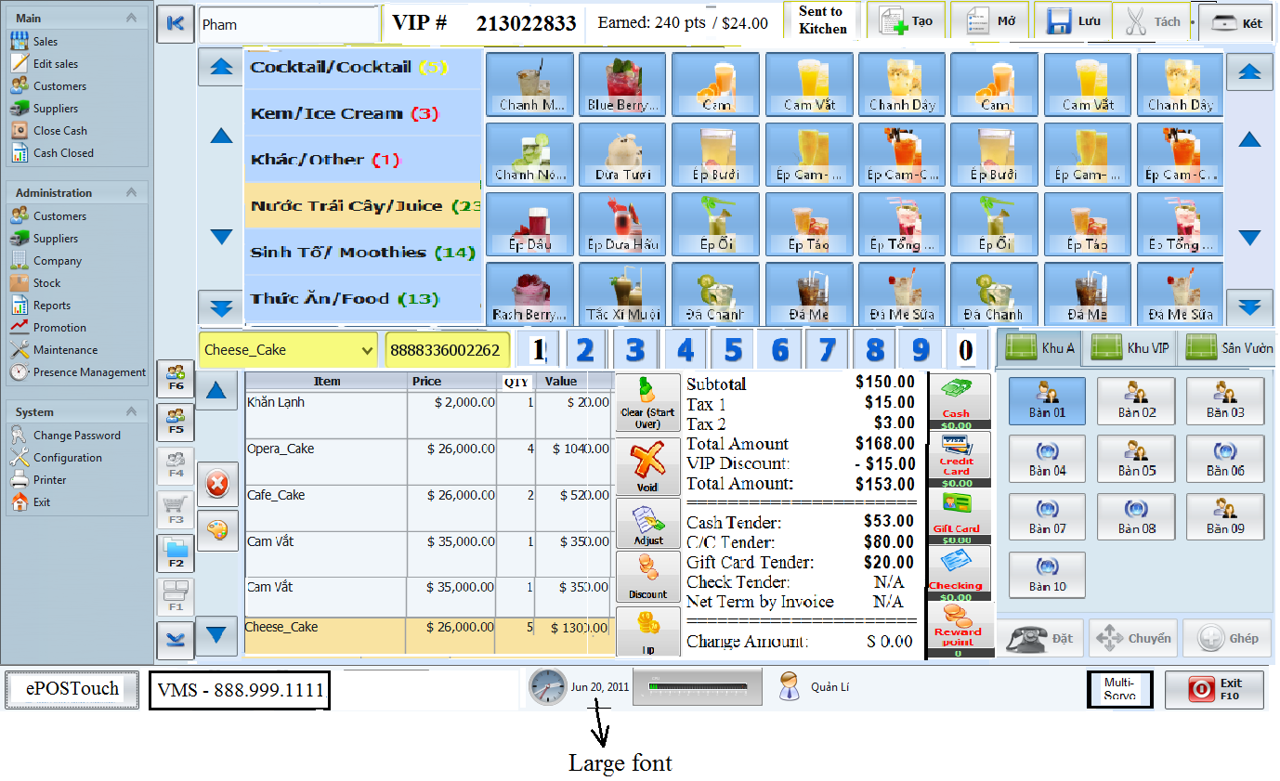

2nd Main Program Layout of Retail store at Server Computer
We can apply this below layout for restail store at this time. However, we need to change to English language, USD formatted, some minor changes below
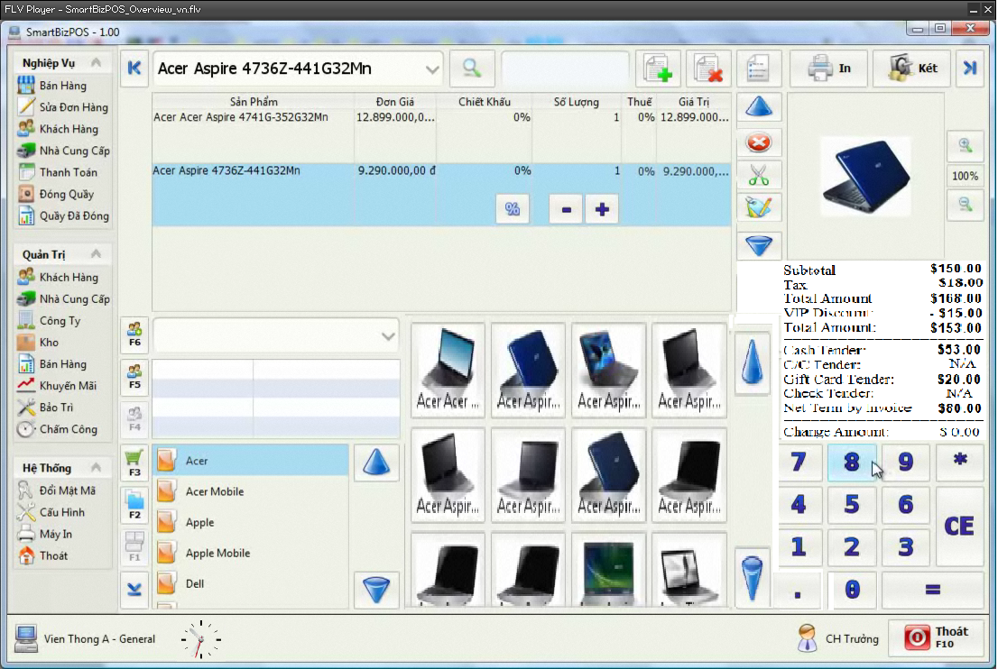

Recurring Payment Setting at Employee’s iPhone: (sample ONLY) but we can do like that)
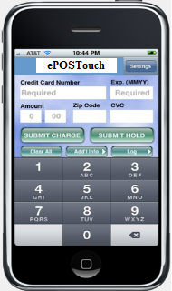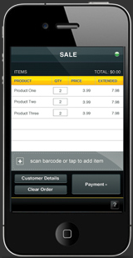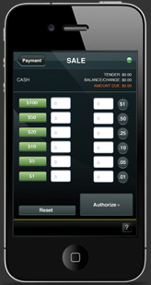
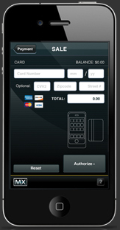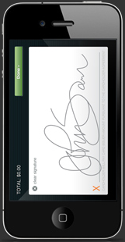

Register ONLINE: (Looks like below)
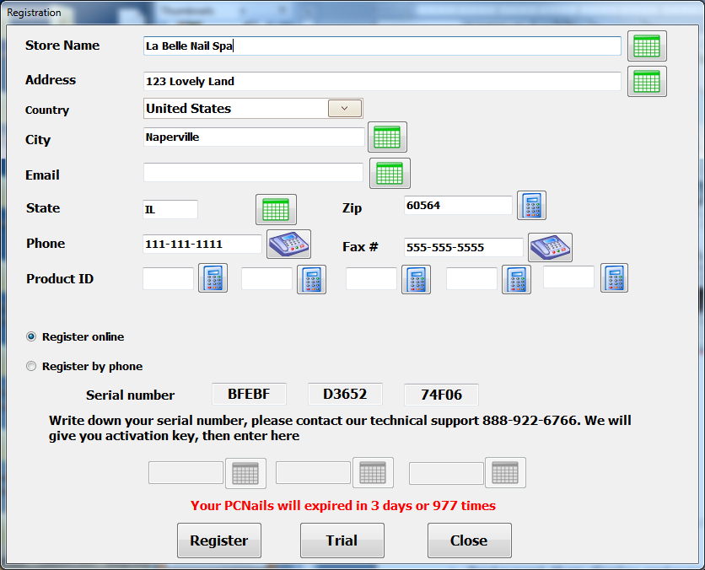
Customer or Sales representative needs to register online (www.epostouch.com). IT also allows 30 days trial. Product ID had 5 groups. Each group had 4 numbers.
Serial Number is generated by Mac Address, Store Name, Address, and Telephone. If both matched in our Database hosted at hosting site then license is valid.

Appointment

Note:
- Phase 1 & 2 is first project, Phase 3 is second project
- Case of Register online is
  - Restaurant then display restaurant template.
  - Nail & SPA then display Nail & SPA template
  - Retailer then display Retailer template.

Service Slip of Nail Salon: WS = Workstation
CLASSY NAILS & SPA
643 E. Boughton Rd. #103
Bolingbrook, IL 60440
(630)972-7200

Service Slip: 001 WS #: 01 Store ID: 12012
Date: 03/15/11 Time: 03:12pm

Service by: ___________________________

SPA PEDICURES
CLASS SIGNATURE PEDICURE 55min /$60
The ultimate indulgence to renew and restore the skin’s moisture and appearance. In an effervescent soak, papaya and guava nectar infused sea salt are combined with a skin.

BASIC MINICURE 30Min /$15

ADDITIONAL SERVICES & TREATMENTS

SOAK OFF $10
With new full set

SUBTOTAL AMOUNT: $85.00

Tips ( ___ Cash ___ Credit Card): _____

TOTAL AMOUNT: _______

COMMENTS

Survey: 1 2 3 4 5 6 7 8 9
(1 = Worst 9 = Best)

Example #1 of POS Receipt CASH ONLY: One customer and one employee served.
CLASSY NAILS & SPA
643 E. Boughton Rd. #103
Bolingbrook, IL 60440
(630)972-7200

Receipt #: 123456 WS #: 01 StoreID: 12012
Service By: Nancy / 2012
Date: 03/15/11 Time: 03:12pm

CLASS SIGNATURE PEDICURE $55.00
Subtotal Amount: $55.00
Tax (8.50%): $4.68
TOTAL AMOUNT: $59.68
Cash Tender: $100.00
Change Amount: $ 40.32

VIP Card Registered: **** **** **** 2128
Original Balance: 0.00
Current Balance: 0.00
Point Earned: 10
Point Balance: 32
Thanks you !!!



Receipt #: 123456 Service By: Nancy / 2012
Date: 03/15/11 Time: 03:12pm

CLASS SIGNATURE PEDICURE $55.00

Example #2 of POS Receipt (CASH / CHECK / GIFTCARD ONLY): Three employees work with one customer per transaction. Total 4 receipts (1 customer, 1 per each employee)
CLASSY NAILS & SPA
643 E. Boughton Rd. #103
Bolingbrook, IL 60440
(630)933-7200

Receipt #: 123456 WS #: 01 StoreID: 12012
Date: 03/15/11 Time: 03:12pm

Service By: Nancy / 2012
CLASS SIGNATURE PEDICURE $55.00

Service By: Tony / 2100
BASIC MINICURE $15.00

Service By: Michelle / 2075
SOAK OFF $10.00

Subtotal Amount: $80.00
Tax (8.50%): $6.80
Discount (10%): - $8.00
TOTAL AMOUNT: $78.80
Cash Tender: $100.00
Change Amount: $13.20
=========================================
Bill Wiliam Registered: **** **** **** 2128
Original Balance: 0.00
Current Balance: 0.00
Point Earned: 10
Point Balance: 32

Thanks you !!!

Paid by CASH then displays
Cash Tender
Paid by Gift Card then displays
Giftcard Tender
Paid by CHECK then displays
Check Tender
Paid by Credit Card then displays C/C Tender
Paid by Cash and Credit Card then display
1st. Line: Cash Tender
2nd. Line: Credit Card Tender
Discount (10%) if membership card has rewarding program then displays it.

If owner store want to have Reward Program then it will print this section out

Receipt #: 123456 Service By: Nancy / 2012
Date: 03/15/11 Time: 03:12pm

CLASS SIGNATURE PEDICURE $55.00

Receipt #: 123456 Service By: Tony / 2100
Date: 03/15/11 Time: 03:12pm

BASIC MINICURE $15.00

Receipt #: 123456 Service By: Michelle / 2075
Date: 03/15/11 Time: 03:12pm

SOAK OFF $10.00

Example #3 of POS Receipt (CREDIT CARD ONLY): TWO employees work with one customer per transaction. Total 4 receipts (1 Detail ticket, 1 for customer, 1 merchant, 1 per each employee)
CLASSY NAILS & SPA
643 E. Boughton Rd. #103
Bolingbrook, IL 60440
(630)972-7200

Receipt #: 123456 WS #: 01 StoreID: 12012
Date: 03/15/11 Time: 03:12pm

Service By: Nancy / 2012
CLASS SIGNATURE PEDICURE $55.00

Service By: Tony / 2100
BASIC MINICURE $15.00

Service By: Michelle / 2075
SOAK OFF $10.00

Subtotal Amount: $80.00
Tax (8.50%): $6.80
TOTAL AMOUNT: $78.80
C/C Tender: $78.80
Change Amount: $0.00
=========================================
VIP Card Registered: **** **** **** 2128
Original Balance: 0.00
Current Balance: 0.00
Point Earned: 10
Point Balance: 32

Thanks you !!!

Receipt #: 123456 Service By: Nancy / 2012
Date: 03/15/11 Time: 03:12pm

CLASS SIGNATURE PEDICURE $55.00

Receipt #: 123456 Service By: Tony / 2100
Date: 03/15/11 Time: 03:12pm

BASIC MINICURE $15.00

Receipt #: 123456 Service By: Michelle / 2075
Date: 03/15/11 Time: 03:12pm

SOAK OFF $10.00

Reward Program: After registered reward program, customer enter username and password
https://oberweis.myguestaccount.com/customer/editinfo.srv user/pwd: baosonil/password

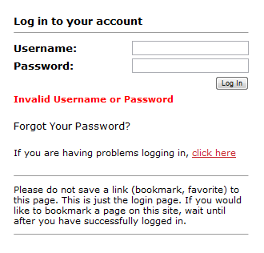
After CLICK HERE
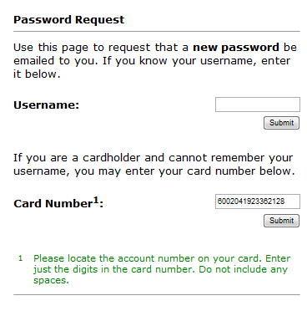

After enter card number and click SUBMIT button

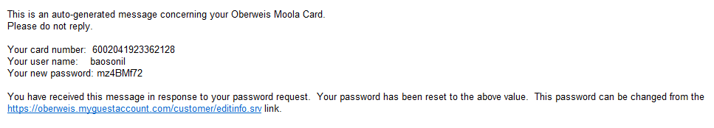
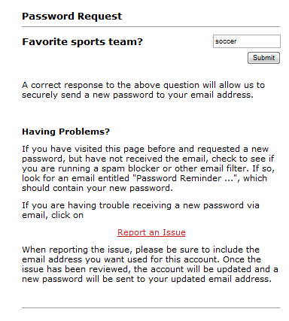

After SUBMIT button
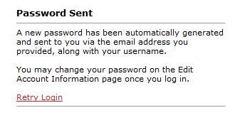

Credit Card of Visa & Master’s Standard Formatted (Explained HERE)
Visa Card: This is international standard Visa Card formatted
%B4389540041600000^PHAM/SON B^14061010000000208000000?; 4389540041600000=140610100000208?

Master Card: This is international standard Master Card formatted
%B5121072733420160^PHAM/BEATRICE B ^1301101143831000000000183000000?; 5121072733420160=1301101143831183?

% Means Track 1
B5121072733420160 Means B is type of credit card category
and 5121072733420160 is Master Card Number of Cardholder.
^ Means a seperator
PHAM/BEATRICE B means PHAM is last name,
/ means a separator between last and first name,
B is initial name.
1301 means 01 is January and 13 is 2013 ( 01/2013)
? means end sentinel

Our GiftCard and Membership Card
%G102210^ePOSTouch^1304?;4782002007813977=
G102210 means Gift Card and 102210 is Store Identification Number (6 Numbers)
ePOSTouch means our company name
1304 means April of 2013
4782002007813977 means gift card number (16 numbers)

Priority Gateway information: (This is TOP Priority)

Documentation of Sale, Void, Refund, Adjust or Tip can be found under:
https://atl.prioritypaymentsystems.com/GatewayAPI/dev/v2.00/Transactions.svc/help
https://atl.prioritypaymentsystems.com/GatewayAPI/dev/v2.00/Transactions.svc/Adjustment/help
https://atl.prioritypaymentsystems.com/GatewayAPI/dev/v2.00/Transactions.svc/Sale/help

MerchantWARE Gateway information
Please use the following link to access our MerchantWARE Transport.WEB documentation. You can use the sample code
http://www.merchantwarehouse.com/downloads/samples/mw3/java/java6se.zip
Please note this sample if for reference purposes only and you will need to change the endpoint to the endpoint listed in the current version of the documentation which was sent to you. You can certainly implement the Tip Adjust and the Repeat Sale (for recurring payments) functions on mobile applications. You just need to make a web service calls from your mobile app using the endpoint provided in the documentation.
You can use the below test card information:
- VISA: 4012000033330026
- Exp Date: 12/12
- CVV: 123

- MC: 5424180279791732
- Exp Date: 12/12
- CVV: 123

This is video clip helping you how it works: https://spos.securenet.com/secureposquickstartvideo.mp4
On the test page, fill in the required fields and click ‘Submit’, the test page will do a POST to our landing page. Take a look at the source code on the page to see how that is passed.
We handle the transaction and afterwards either display a result page with the results in the URL or if the RedirectLocation URL is passed, we redirect the page to that URL and attach the response in the URL.
Following is the link where you would need to POST the data to from your POS:
https://staging.merchantware.net/transportweb/transportweb.aspx

The web service documentation for all the other functions (refund, tip adjust, void, repeat sale etc.) is located at the following link:
https://staging.merchantware.net/merchantware/doc/RetailTX.aspx
You can use the same test credentials that are listed in the email above to test these functions as well.

Any technical support issues, please attached is a Test Script for you to fill out and return to integrations@merchantwarehouse.com after you have completed the integration process. Once we have received this completed form, we will verify that the transactions are processed properly and certify your application for processing using MerchantWARE Transport.WEB. You will a response from us within 24 hours. Please feel free to contact us if you have any questions or run into any issues.
NOTE: cc to my email address: pcnails@yahoo.com

Pictures applied for Petty Cash
Definition: Petty cash refers to small amounts of cash kept on hand in a business. (The term "petty" comes from "petite," or "small.") There are two reasons to keep petty cash:
- To make change for customers or patients
- To pay for small purchases which require cash, such as food for the office lunch or coffee supplies, or for parking. Most retail businesses keep a cash drawer as do health care practices.
Dollar Bills
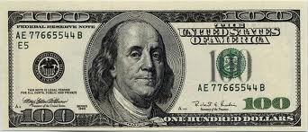
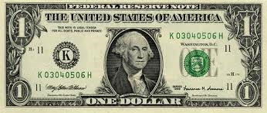

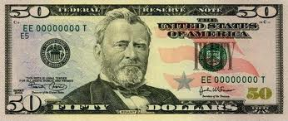

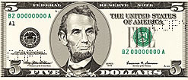
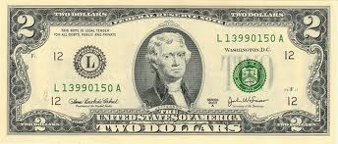
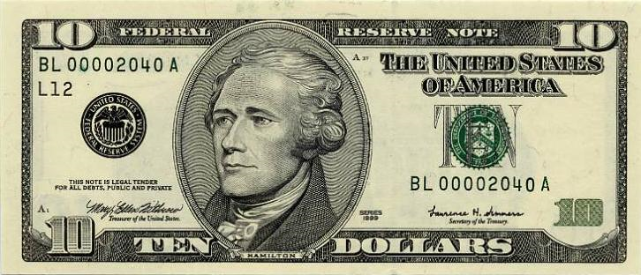

Cash Drawer
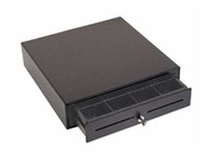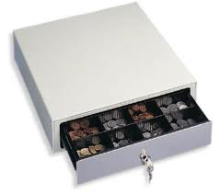
Cryptography: (Encryption and Decryption)
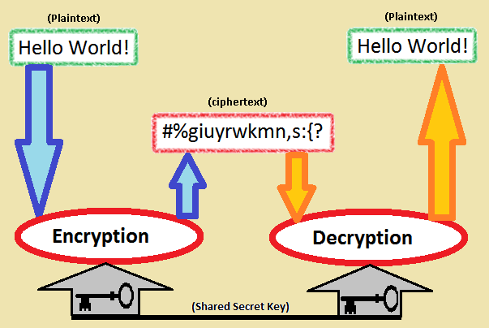

Reference List:
- TouchSuite Salon Hair & Salon SPA
- Appointment on iPhone with Vagaro Professional Appointment on an iPhone
- Appointment on Desktop, iPad or TabletPC Appointment on iPad
- Appointment on Desktop (Rosy Company) Appointment on Desktop PC
- Web Based Point of Sale Web Point of Sales Demo
- Cloud Based Point Of Sale System How to design keypad
- http://www.youtube.com/watch?v=cJ1rQyjogLg&feature=related Restaurant POS software DEMO
- http://www.youtube.com/watch?v=xQLojWB9k1Y&feature=related (Lock in/out and paid multiple credit card)
- http://revelsystems.com/demo/m (iPad)
- http://www.magneprint.com/ What is Magnetic Reader?
- http://code.google.com/apis/loader/signup.html Sign up for Google Search API
- http://www.posterita.com/ Want www.epostouch.com looks like this site
- http://en.wikipedia.org/wiki/Magnetic_stripe About Magnetic Stripe of credit card, giftcard, …
- http://en.wikipedia.org/wiki/Cryptography Encryption and Decryption
- https://spos.securenet.com/secureposquickstartvideo.mp4 Integrated with Gateway API (Sale, Tip, Void, Refund)

Each package includes all of the following features:

Administrator Console
Enable you to view and customize every feature of this system including managing your clientele and employees, organizing your product inventory and generating financial reports.

Appointment Book (Salon appointment scheduling program)
Book, move and cancel appointments on one central scheduling page more easily and quicker than with other salon appointment software. Simply input client’s contact information, date, time, and operator and services requested.

SMS Appointment Confirmation
Confirming appointments is one of the most important and yet often overlooked tasks to ensure your business

Point of Sale (POS salon software)
When clients are lined up at the reception desk, you don’t have time to struggle with salon POS software that is slow and hard to use. Our system allows you to quickly check out customers for services provided as well as additional product sales including gift cards. All transactions are automatically added to the daily transaction summary.

Online Client Scheduling
With our innovative client scheduling feature your customers can enjoy the convenience of scheduling their own appointments and purchasing products or gift certificates whenever they want - 24 hours a day 7 days a week.

Inventory Management
Products are automatically deducted from your inventory each time a sale is made. Organize and manage your products by brand and keep track of your vendor records as well.

Customer Management
View all of your existing customers that have been entered into the system database. Keep track of each client’s personal history including past services, the operator who attended them and merchandise purchases. You can also manage gift card redemption - what amount has been used and how much is still available for each client.

Employee Management
Manage your employee schedules with just a few simple clicks. Show services provided by each employee, name of their clients, products sold and staff commission.

Accounting
Provides detailed outlook which allows you to manage your income with a day by day layout for every transaction that has occurred. View the opening, gross sales, and closing cash count for any specific date. Since the system is always backed up and never needs to be restored, you can simply choose the specific date to review all the way back to the first day you used the program.

Reporting Console
Creates easy to understand sales and operations reports with colorful graphs that provide valuable information to help you effectively manage your business. You can generate sales reports for the day, week or month.

SMS Appointment Confirmation
Creates easy to understand sales and operations reports with colorful graphs that provide valuable information to help you effectively manage your business. You can generate sales reports for the day, week or month.

Enhanced Security
All ePOSTouch accounts are password protected for your security and include SSL 128-bit encryption, which means that all data sent between ePOSTouch and your computer is safely encrypted from viewing by unauthorized individuals. It's the same technology used by online banks and e-commerce sites to keep your credit card information safe:

Your data is protected
All data is backed up on a daily basis and stored in several different locations on secure state-of-the-art servers that are protected against unauthorized entry and security breaches.

Routine system updates
Our sophisticated system infrastructure is updated frequently with the latest security patches. Our system operates on a dedicated network protected by firewalls and routinely monitored to ensure your data is safe.

Protection against system failure
By operating full redundancy, we have taken the necessary precautions to make certain our system is fully operational at all times even if multiple servers should fail.

Your billing information is safe
We use the same type of secure encryption used by banks to process your credit card transactions. A PCI-compliant network is utilized to transmit, store and process all credit card information.

